**1**

**2**

**CERTIFICATE**

**This is to certify that this dissertation entitled “ ORGANIC MANURE “ submitted to Mahatma Gandhi University by**

**Sandhra Anna Jerry , Reg.No:200021096553 , Bachelor of Computer Applications ,**

**in partial-fulfilment of the requirements for the MOOC on Organic Farming is carried out by her under my guidance**

**SPASIBA SUNIL**

**ASSISTANT PROFESSOR**

**Department of Computer Science**

**Sahodaran Ayyappan Smaraka SNDP Yogam College**

**Konni**

**3**

**DECLARATION**

**I hereby declare that the project report on “Organic Manure” submitted to the Mahatma Gandhi University in partial fulfilment of the requirements for the MOOC on Organic Farming is done by me under the guidance of**

**Spasiba Sunil**

**Assistant Professor**

**Department of Computer Science**

**Sahodaran Ayyappan Smaraka SNDP Yogam College**

**Konni**

**Konni**

**11.07.2022**

**4**

**CONTENTS**

**Abstract 5**

**Introduction 6**

**Materials Required 7**

**Composting process 8**

**Conclusion 12**

**5**

**ABSTRACT**

**Researcher : Sandhra Anna Jerry**

**Presentation Title : Organic Manure**

**University : Mahatma Gandhi University**

**Student Level : Undergraduate**

Conversion of organic wastes generated at the household level to useful materials like manure is the theme of this project. Per capita waste generation in India is estimated to be around 500 grams per day. A nuclear family of 4-5 members generates 2 to 2.5kg of wastes per household. Organic wastes generated at household levels can be processed at the source itself.

Decentralized waste processing is more practical and cost-effective than a centralized one. It is the responsibility of each individual to process the waste generated by him/her. Therefore the purpose of this project is to get familiarized with the different biotechnological means to process the household and kitchen wastes to valuable manure at the household level.

6

**INTRODUCTION**

Composting is the natural process of decomposition and recycling of organic material into a humus-rich soil amendment known as compost. Compost is made with materials such as leaves , shredded twigs , and kitchen scraps from plants. To gardeners , compost is “black gold” because of its many benefits in the garden. Food waste is composed of organic matter which can be used for composting to make fertilizers. It is an effective and eco-friendly way of decomposing of food wastes in our kitchen. By using leftovers and other food waste, one can convert these smelly things from kitchen waste into an organic product , rich in nutrients that can be used to grow vegetables and fruits. And the method which is used for this project is “Garden Pot Composting”.

**Why use food waste as fertilizer?**

Food waste is a major challenge in the present world. Tons of food is thrown away in the garbage daily. We could use all these food waste and prepare a compost out of them which can be used as organic fertilizer. This way , we can save the Earth from pollution caused by food wastes and also do something productive to the nature.

**Benefits of composting**

* Increases microbial activity
* Enhances plant disease suppression
* Increases soil fertility
* Improves soil fertility
* Improves soil structure in clayey soils
* Improves water retention in sandy soils
* Reduces bioavailability of heavy metals
* Increases cation exchange capacity

7

Compost commonly contain about 2% nitrogen , 0.5-1% phosphorus , and about 2% potassium. Because of their fairly low nutrient content , composts are usually applied in large amounts.

**Materials Required**

1. Kitchen waste including vegetable waste , fish waste , food waste , etc. Waste shall be devoid of plastics , oily materials , bottles , and liquefied food wastes.
2. Bio bins to hold the kitchen waste. Bio bins can be earthen made similar to garden pots or PVC pipes of 200 mm diameter. Micro pores on the bin walls ensure aeration that facilitates microbial activity. The holes in the bottom of these pots are then closed using cement mortar.
3. Composting inoculums are consortia of microflora that can easily decompose vegetable and food wastes. They include bacterial and fungal stains. Microbial inoculation with specific bacteria and/or enzyme-producing microbes can enhance the composting process by ensuring the right microbes are in the right temperature, oxygen , and moisture regimes in the piles at the right times.

**How to prepare inoculums?**

Take 100g of jaggery , 1.5g of waste decomposer and mix it well in a plastic drum containing 10 litres of water. Use a wooden stick for stirring. Now cover the drum properly and stir it well once or twice for the next week. After 7 days, the solution turns creamy in texture , which means it is ready for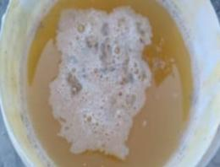use.

8

**COMPOSTING PROCESS**

Large garden pots are the simplest and cheapest containers for kitchen waste composting. The base holes of the pot are closed , if there are any. At the bottom of the pot , a layer of soil and dry leaves are spread at 1” thickness.

Above this layer , spread the kitchen waste of the day. The bin may be covered with a tile or wooden plank. This process of filling and addition of inoculum should be continued daily. The moisture within the bin has to be regulated by spreading coir pith or dry leaves. A little bit of water can also be added.

Now after 7 days open the pot and stir its contents for a while. It can accelerate the decomposition process. After 30 to 35 days of the last filling , the compost is taken out. The brown colored compost in powder form is quality manure that can that can be used for nourishing crops including vegetables and fruits.

9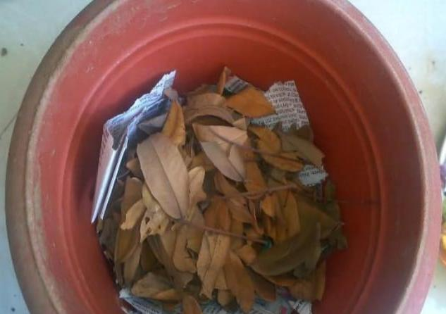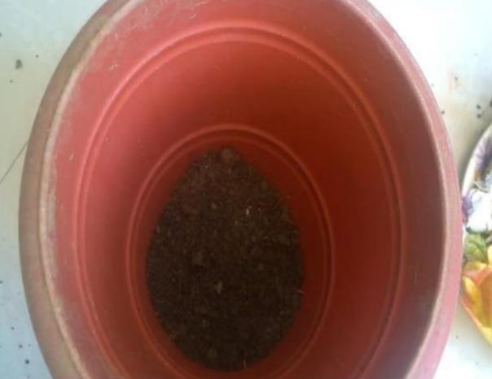

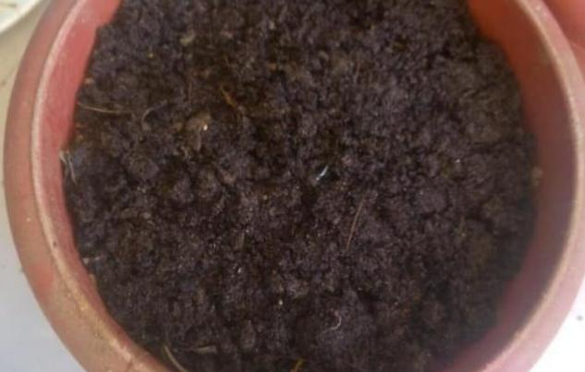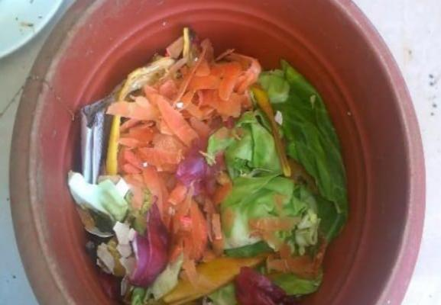

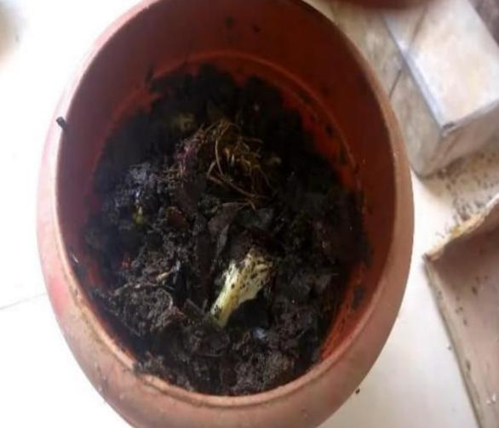10

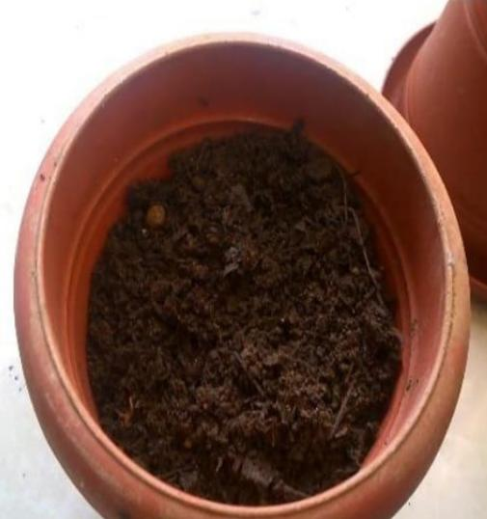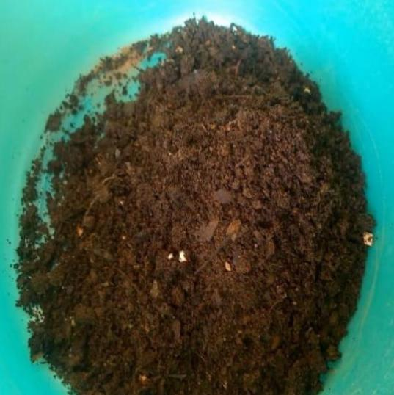

11

**CONCLUSION**

Composting , as a treatment of organic waste , had been proven to significantly reduce the volume of wastes in the country. In addition , composting can also provide nutrients that are suitable for agriculture and can be used as fertilizer to replace chemical fertilizer. Furthermore , compost can also be used as soil amendments as well as being eco-friendly , hygienic , economical and toxic free. Proper management of solid wastes reduces or eliminates adverse impacts on the environment , human health and supports economical developmentfor the better quality of life. The productivity of agricultural land and soil quality needs improvement. Therefore , the aim of this study was to convert kitchen waste into a useful product for better growth and quality of crops and thus this low cost technology has a very high economic , environmental and social relevance.